www.sensorsportal.com | IFSA Publishing
NEW
S. Yatsyshyn and B. Stadnyk, Editors,
National University Lviv Polytechnic, Ukrain

Cyber-Physical Systems. Metrological Issues

This book presents and considers main trends in the branch of metrology of cyber-physical systems, which are becoming a key element of everyday life. First of all it is destined for engineers, lecturers, students, persons who are not acquainted enough with specificity of cyber-physical systems and their metrology but are interested in it. The authors tried to highlight emergence and development of these systems, combined with the study of their metrology provision and support.

2016, 326 p., hardcover € 129.95 and e-book (pdf) € 99.95
ISBN: 978-84-608-9962-4
e-ISBN: 978-84-617-6200-2
BIC: TBM
Order: publisher@sensorsportal.com

Contents:

About the Authors

Acknowledgement

List of Abbreviations

Chapter 1. Introduction

Chapter 2. Smart Measuring Instruments

Chapter 3. Embedded Measures as the Measuring Instruments

Chapter 4. Code-Controllable Measures for Correction of Measuring Channels

Chapter 5. Techniques for Accuracy/Trueness Improvement

Chapter 6. Frequency, Noise and Spectrum Metrology

Chapter 7. Qualimetric Estimation of CPSs and Their Products

Index

LIBRARY RECOMMENDATION FORM

To the Librarian/Information Specialist:

I would like to recommend the following title from IFSA Publishing as a valuable addition to the organization’s collection of scientific and technical information resources:

TITLE RECOMMENDATION:

ISBN: 978-84-608-9962-4
e-ISBN: 978-84-617-6200-2
BIC: TBM
Editors: S. Yatsyshyn and B. Stadnyk
Title: Cyber-Physical Systems. Metrological Issues , 326 p.
Pubdate: 5 November 2016
Price: 99.95 EUR for book in printable Acrobat (pdf) format and 129.95 EUR for print book in hardcover
Place order by e-mail: publisher@sensorsportal.com

I need to refer to this information frequently in the course of my work.
This information is directly related to my field and is an important source of information for my research.
It is critical that students have access to this information to best facilitate their course work and academic pursuits.
Additional reasons: ______________________________________________________________

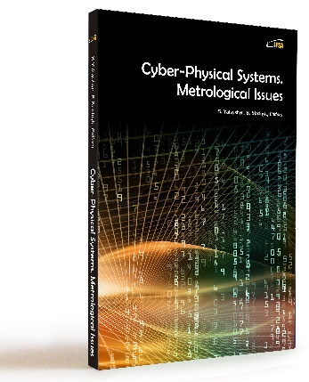

Signature: _______________________________Date: _________________
Name: ________________________________________________________
Title: _________________________________________________________
Department: ___________________________________________________
Telephone Number: ____________________________________________
E-mail Address: ________________________________________________

Visit IFSA Publishing online at
http://www.sensorsportal.com/HTML/IFSA_Publishing.htm

